Web Services Tutorial

Web services are open standard (XML, SOAP, HTTP etc.) based Web applications that interact with other web applications for the purpose of exchanging data.
Web Services can convert your existing applications into Web-applications.
In this tutorial you will learn what exactly Web Services are and Why and How to use them.

What are Web Services?

Different books and different organizations provide different definitions to Web Services. Some of them are listed here.
A web service is any piece of software that makes itself available over the internet and uses a standardized XML messaging system. XML is used to encode all communications to a web service. For example, a client invokes a web service by sending an XML message, then waits for a corresponding XML response. As all communication is in XML, web services are not tied to any one operating system or programming language--Java can talk with Perl; Windows applications can talk with Unix applications.

Web services are self-contained, modular, distributed, dynamic applications that can be described, published, located, or invoked over the network to create products, processes, and supply chains. These applications can be local, distributed, or web-based. Web services are built on top of open standards such as TCP/IP, HTTP, Java, HTML, and XML.

Web services are XML-based information exchange systems that use the Internet for direct application-to-application interaction. These systems can include programs, objects, messages, or documents.

A web service is a collection of open protocols and standards used for exchanging data between applications or systems. Software applications written in various programming languages and running on various platforms can use web services to exchange data over computer networks like the Internet in a manner similar to inter-process communication on a single computer. This interoperability (e.g., between Java and Python, or Windows and Linux applications) is due to the use of open standards.

To summarize, a complete web service is, therefore, any service that:

Is available over the Internet or private (intranet) networks
Uses a standardized XML messaging system
Is not tied to any one operating system or programming language
Is self-describing via a common XML grammar
Is discoverable via a simple find mechanism
Components of Web Services
The basic web services platform is XML + HTTP. All the standard web services work using the following components
SOAP (Simple Object Access Protocol)
UDDI (Universal Description, Discovery and Integration)
WSDL (Web Services Description Language)
All these components have been discussed in the Web Services Architecture chapter.
How Does a Web Service Work?
A web service enables communication among various applications by using open standards such as HTML, XML, WSDL, and SOAP. A web service takes the help of:
XML to tag the data
SOAP to transfer a message
WSDL to describe the availability of service.
You can build a Java-based web service on Solaris that is accessible from your Visual Basic program that runs on Windows.
You can also use C# to build new web services on Windows that can be invoked from your web application that is based on JavaServer Pages (JSP) and runs on Linux.
Example
Consider a simple account-management and order processing system. The accounting personnel use a client application built with Visual Basic or JSP to create new accounts and enter new customer orders.
The processing logic for this system is written in Java and resides on a Solaris machine, which also interacts with a database to store information.
The steps to perform this operation are as follows:
The client program bundles the account registration information into a SOAP message.
This SOAP message is sent to the web service as the body of an HTTP POST request.

The web service unpacks the SOAP request and converts it into a command that the application can understand.
The application processes the information as required and responds with a new unique account number for that customer.
Next, the web service packages the response into another SOAP message, which it sends back to the client program in response to its HTTP request.
The client program unpacks the SOAP message to obtain the results of the account registration process.

Why Web Services?

Exposing the Existing Function on the network

A web service is a unit of managed code that can be remotely invoked using HTTP, that is, it can be activated using HTTP requests. Web services allows you to expose the functionality of your existing code over the network. Once it is exposed on the network, other application can use the functionality of your program.

Interoperability

Web services allow various applications to talk to each other and share data and services among themselves. Other applications can also use the web services. For example, a VB or .NET application can talk to Java web services and vice versa. Web services are used to make the application platform and technology independent.

Standardized Protocol

Web services use standardized industry standard protocol for the communication. All the four layers (Service Transport, XML Messaging, Service Description, and Service Discovery layers) use well-defined protocols in the web services protocol stack. This standardization of protocol stack gives the business many advantages such as a wide range of choices, reduction in the cost due to competition, and increase in the quality.

Low Cost of Communication

Web services use SOAP over HTTP protocol, so you can use your existing low-cost internet for implementing web services. This solution is much less costly compared to proprietary solutions like EDI/B2B. Besides SOAP over HTTP, web services can also be implemented on other reliable transport mechanisms like FTP.

Web Services - Characteristics

XML-Based

Web Services uses XML at data representation and data transportation layers. Using XML eliminates any networking, operating system, or platform binding. Web Services based applications are highly interoperable application at their core level.

Loosely Coupled

A consumer of a web service is not tied to that web service directly. The web service interface can change over time without compromising the client's ability to interact with the service. A tightly coupled system implies that the client and server logic are closely tied to one another, implying that if one interface changes, the other must be updated. Adopting a loosely coupled architecture tends to make software systems more manageable and allows simpler integration between different systems.

Coarse-Grained

Object-oriented technologies such as Java expose their services through individual methods. An individual method is too fine an operation to provide any useful capability at a corporate level. Building a Java program from scratch requires the creation of several fine-grained methods that are then composed into a coarse-grained service that is consumed by either a client or another service.

Businesses and the interfaces that they expose should be coarse-grained. Web services technology provides a natural way of defining coarse-grained services that access the right amount of business logic.

Ability to be Synchronous or Asynchronous

Synchronicity refers to the binding of the client to the execution of the service. In synchronous invocations, the client blocks and waits for the service to complete its operation before continuing. Asynchronous operations allow a client to invoke a service and then execute other functions.

Asynchronous clients retrieve their result at a later point in time, while synchronous clients receive their result when the service has completed. Asynchronous capability is a key factor in enabling loosely coupled systems.

Supports Remote Procedure Calls(RPCs)

Web services allow clients to invoke procedures, functions, and methods on remote objects using an XML-based protocol. Remote procedures expose input and output parameters that a web service must support.

Component development through Enterprise JavaBeans (EJBs) and .NET Components has increasingly become a part of architectures and enterprise deployments over the past couple of years. Both technologies are distributed and accessible through a variety of RPC mechanisms.

A web service supports RPC by providing services of its own, equivalent to those of a traditional component, or by translating incoming invocations into an invocation of an EJB or a .NET component.

Supports Document Exchange

One of the key advantages of XML is its generic way of representing not only data, but also complex documents. These documents can be as simple as representing a current address, or they can be as complex as representing an entire book or Request for Quotation (RFQ). Web services support the transparent exchange of documents to facilitate business integration.

Web Services - Architecture

There are two ways to view the web service architecture:

The first is to examine the individual roles of each web service actor.

The second is to examine the emerging web service protocol stack.

Web Service Roles

There are three major roles within the web service architecture:

Service Provider

This is the provider of the web service. The service provider implements the service and makes it available on the Internet.

Service Requestor

This is any consumer of the web service. The requestor utilizes an existing web service by opening a network connection and sending an XML request.

Service Registry

This is a logically centralized directory of services. The registry provides a central place where developers can publish new services or find existing ones. It therefore serves as a centralized clearing house for companies and their services.

Web Service Protocol Stack

A second option for viewing the web service architecture is to examine the emerging web service protocol stack. The stack is still evolving, but currently has four main layers.

Service Transport

This layer is responsible for transporting messages between applications. Currently, this layer includes Hyper Text Transport Protocol (HTTP), Simple Mail Transfer Protocol (SMTP), File Transfer Protocol (FTP), and newer protocols such as Blocks Extensible Exchange Protocol (BEEP).

XML Messaging

This layer is responsible for encoding messages in a common XML format so that messages can be understood at either end. Currently, this layer includes XML-RPC and SOAP.

Service Description

This layer is responsible for describing the public interface to a specific web service. Currently, service description is handled via the Web Service Description Language (WSDL).

Service Discovery

This layer is responsible for centralizing services into a common registry and providing easy publish/find functionality. Currently, service discovery is handled via Universal Description, Discovery, and Integration (UDDI).

As web services evolve, additional layers may be added and additional technologies may be added to each layer.

Few Words about Service Transport

The bottom of the web service protocol stack is service transport. This layer is responsible for actually transporting XML messages between two computers.

Hyper Text Transfer Protocol (HTTP)

Currently, HTTP is the most popular option for service transport. HTTP is simple, stable, and widely deployed. Furthermore, most firewalls allow HTTP traffic. This allows XML-RPC or SOAP messages to masquerade as HTTP messages. This is good if you want to integrate remote applications, but it does raise a number of security concerns.

Blocks Extensible Exchange Protocol (BEEP)

This is a promising alternative to HTTP. BEEP is a new Internet Engineering Task Force (IETF) framework for building new protocols. BEEP is layered directly on TCP and includes a number of built-in features, including an initial handshake protocol, authentication, security, and error handling. Using BEEP, one can create new protocols for a variety of applications, including instant messaging, file transfer, content syndication, and network management.

SOAP is not tied to any specific transport protocol. In fact, you can use SOAP via HTTP, SMTP, or FTP. One promising idea is therefore to use SOAP over BEEP.

Web Services - Components

Over the past few years, three primary technologies have emerged as worldwide standards that make up the core of today's web services technology. These technologies are discussed below.

XML-RPC
This is the simplest XML-based protocol for exchanging information between computers.
- XML-RPC is a simple protocol that uses XML messages to perform RPCs.
- Requests are encoded in XML and sent via HTTP POST.
- XML responses are embedded in the body of the HTTP response.
- XML-RPC is platform-independent.
- XML-RPC allows diverse applications to communicate.
- A Java client can speak XML-RPC to a Perl server.
- XML-RPC is the easiest way to get started with web services.

SOAP
SOAP is an XML-based protocol for exchanging information between computers.
- SOAP is a communication protocol.
- SOAP is for communication between applications.
- SOAP is a format for sending messages.
- SOAP is designed to communicate via Internet.
- SOAP is platform independent.
- SOAP is language independent.
- SOAP is simple and extensible.
- SOAP allows you to get around firewalls.
- SOAP will be developed as a W3C standard.

WSDL
WSDL is an XML-based language for describing web services and how to access them.
- WSDL stands for Web Services Description Language.
- WSDL was developed jointly by Microsoft and IBM.
- WSDL is an XML based protocol for information exchange in decentralized and distributed environments.
- WSDL is the standard format for describing a web service.
- WSDL definition describes how to access a web service and what operations it will perform.
- WSDL is a language for describing how to interface with XML-based services.
- WSDL is an integral part of UDDI, an XML-based worldwide business registry.
- WSDL is the language that UDDI uses.
- WSDL is pronounced as 'wiz-dull' and spelled out as 'W-S-D-L'.

UDDI
UDDI is an XML-based standard for describing, publishing, and finding web services.
- UDDI stands for Universal Description, Discovery, and Integration.
- UDDI is a specification for a distributed registry of web services.
- UDDI is platform independent, open framework.
- UDDI can communicate via SOAP, CORBA, and Java RMI Protocol.
- UDDI uses WSDL to describe interfaces to web services.
- UDDI is seen with SOAP and WSDL as one of the three foundation standards of web services.
- UDDI is an open industry initiative enabling businesses to discover each other and define how they interact over the Internet.

Web Services - Security
Security is critical to web services. However, neither XML-RPC nor SOAP specifications make any explicit security or authentication requirements.
There are three specific security issues with web services:
- Confidentiality
- Authentication
- Network Security
Confidentiality
If a client sends an XML request to a server, can we ensure that the communication remains confidential?
Answer lies here:
XML-RPC and SOAP run primarily on top of HTTP.
HTTP has support for Secure Socketes Layer (SSL).
Communication can be encrypted via SSL.
SSL is a proven technology and widely deployed.
A single web service may consist of a chain of applications. For example, one large service might tie together the services of three other applications. In this case, SSL is not adequate; the messages need to be encrypted at each node along the service path, and each node represents a potential weak link in the chain. Currently, there is no agreed-upon solution to this issue, but one promising solution is the W3C XML Encryption Standard. This standard provides a framework for encrypting and decrypting entire XML documents or just portions of an XML document.

Authentication
If a client connects to a web service, how do we identify the user? Is the user authorized to use the service?
The following options can be considered but there is no clear consensus on a strong authentication scheme.
- HTTP includes built-in support for Basic and Digest authentication, and services can therefore be protected in much the same manner as HTML documents are currently protected.
- SOAP Digital Signature (SOAP-DSIG) leverages public key cryptography to digitally sign SOAP messages. It enables the client or server to validate the identity of the other party. Check it athttp://www.w3.org/TR/SOAP-dsig.
- The Organization for the Advancement of Structured Information Standards (OASIS) is working on the Security Assertion Markup Language (SAML).

Network Security
There is currently no easy answer to this problem, and it has been the subject of much debate. For now, if you are truly intent on filtering out SOAP or XML-RPC messages, one possibility is to filter out all HTTP POST requests that set their content type to text/xml.
Another alternative is to filter the SOAPAction HTTP header attribute. Firewall vendors are also currently developing tools explicitly designed to filter web service traffic.

Web Services - Standards

Transports
BEEP, the Blocks Extensible Exchange Protocol (formerly referred to as BXXP), is a framework for building application protocols. It has been standardized by IETF and it does for Internet protocols what XML has done for data.
- Blocks Extensible Exchange Protocol (BEEP)

Messaging
These messaging standards and specifications are intended to give a framework for exchanging information in a decentralized, distributed environment.
- SOAP 1.1 (Note)
- SOAP 1.2 (Specification)
- Web Services Attachments Profile 1.0
- SOAP Message Transmission Optimization Mechanism

Description and discovery
Web services are meaningful only if potential users may find information sufficient to permit their execution. The focus of these specifications and standards is the definition of a set of services supporting the description and discovery of businesses, organizations, and other web services providers; the web services they make available; and the technical interfaces which may be used to access those services.

Security
Using these security specifications, applications can engage in secure communication designed to work with the general web services framework.
- Web Services Security 1.0
- Security Assertion Markup Language (SAML)

Management
Web services manageability is defined as a set of capabilities for discovering the existence, availability, health, performance, usage, as well as the control and configuration of a web service within the web services architecture. As web services become pervasive and critical to business operations, the task of managing and implementing them is imperative to the success of business operations.

XML-RPC Tutorial

XML-RPC is the simplest XML-based protocol for exchanging information between computers across a network.

XML-RPC - Introduction
RPC stands for Remote Procedure Call. As its name indicates, it is a mechanism to call a procedure or a function available on a remote computer. RPC is a much older technology than the Web. Effectively, RPC gives developers a mechanism for defining interfaces that can be called over a network. These interfaces can be as simple as a single function call or as complex as a large API.

What is XML-RPC ?
XML-RPC is among the simplest and most foolproof web service approaches that makes it easy for computers to call procedures on other computers.
- XML-RPC permits programs to make function or procedure calls across a network.
- XML-RPC uses the HTTP protocol to pass information from a client computer to a server computer.
- XML-RPC uses a small XML vocabulary to describe the nature of requests and responses.
- XML-RPC client specifies a procedure name and parameters in the XML request, and the server returns either a fault or a response in the XML response.
- XML-RPC parameters are a simple list of types and content - structs and arrays are the most complex types available.
- XML-RPC has no notion of objects and no mechanism for including information that uses other XML vocabulary.
- With XML-RPC and web services, however, the Web becomes a collection of procedural connections where computers exchange information along tightly bound paths.
- XML-RPC emerged in early 1998; it was published by UserLand Software and initially implemented in their Frontier product.

Why XML-RPC?
If you need to integrate multiple computing environments, but don't need to share complex data structures directly, you will find that XML-RPC lets you establish communications quickly and easily.
Even if you work within a single environment, you may find that the RPC approach makes it easy to connect programs that have different data models or processing expectations and that it can provide easy access to reusable logic.
- XML-RPC is an excellent tool for establishing a wide variety of connections between computers.
- XML-RPC offers integrators an opportunity to use a standard vocabulary and approach for exchanging information.
- XML-RPC's most obvious field of application is connecting different kinds of environments, allowing Java to talk with Perl, Python, ASP, and so on.

XML-RPC Technical Overview
XML-RPC consists of three relatively small parts:
- XML-RPC data model: A set of types for use in passing parameters, return values, and faults (error messages).
- XML-RPC request structures: An HTTP POST request containing method and parameter information.
- XML-RPC response structures: An HTTP response that contains return values or fault information.
      - XML-RPC - Data Model
The XML-RPC specification defines six basic data types and two compound data types that represent combinations of types.

Basic Data Types in XML-RPC
Type | Value | Examples
int or i4 | 32-bit integers between - 2,147,483,648 and 2,147,483,647. | <int>27</int>  <i4>27</i4>
double | 64-bit floating-point numbers | <double>27.31415</double>  <double>-1.1465</double>
Boolean | true (1) or false (0) | <boolean>1</boolean>  <boolean>0</boolean>
string | ASCII text, though many implementations support Unicode | <string>Hello</string>  <string>bonkers! @</string>
dateTime.iso8601 | Dates in ISO8601 format: CCYYMMDDTHH:MM:SS | <dateTime.iso8601>  20021125T02:20:04  </dateTime.iso8601>  <dateTime.iso8601>  20020104T17:27:30  </dateTime.iso8601>
base64 | Binary information encoded as Base 64, as defined in RFC 2045 | <base64>SGVsbG8sIFdvcmxkIQ==</base64>
These basic types are always enclosed in value elements. Strings (and only strings) may be enclosed in a value element but omit the string element. These basic types may be combined into two more complex types, arrays, and structs. Arrays represent sequential information, while structs represent name-value pairs, much like hashtables, associative arrays, or properties.
Arrays are indicated by the array element, which contains a data element holding the list of values. Like other data types, the array element must be enclosed in a value element. For example, the following arraycontains four strings:
- <value>
- <array>
- <data>
- <value><string>This </string></value>
- <value><string>is </string></value>
- <value><string>an </string></value>
- <value><string>array.</string></value>
- </data>
- </array>
- </value>
The following array contains four integers:
- <value>
- <array>
- <data>
- <value><int>7</int></value>
- <value><int>1247</int></value>
- <value><int>-91</int></value>
- <value><int>42</int></value>
- </data>
- </array>
- </value>
Arrays can also contain mixtures of different types, as shown here:
- <value>
- <array>
- <data>
- <value><boolean>1</boolean></value>
- <value><string>Chaotic collection, eh?</string></value>
- <value><int>-91</int></value>
- <value><double>42.14159265</double></value>
- </data>
- </array>
- </value>
Creating multidimensional arrays is simple - just add an array inside of an array:
- <value>
- <array>
- <data>

- <value>
- <array>
- <data>
- <value><int>10</int></value>
- <value><int>20</int></value>
- <value><int>30</int></value>
- </data>
- </array>
- </value>

- <value>
- <array>
- <data>
- <value><int>15</int></value>
- <value><int>25</int></value>
- <value><int>35</int></value>
- </data>
- </array>
- </value>

- </data>
- </array>
- </value>
A simple struct might look like:
- <value>
- <struct>
- <member>
- <name>givenName</name>
- <value><string>Joseph</string></value>
- </member>

- <member>
- <name>familyName</name>
- <value><string>DiNardo</string></value>
- </member>

- <member>
- <name>age</name>
- <value><int>27</int></value>
- </member>
- </struct>
- </value>

XML-RPC - Request Format

XML-RPC requests are a combination of XML content and HTTP headers. The XML content uses the data typing structure to pass parameters and contains additional information identifying which procedure is being called, while the HTTP headers provide a wrapper for passing the request over the Web.
Each request contains a single XML document, whose root element is amethodCall element. Each methodCall element contains a methodNameelement and a params element. The methodName element identifies the name of the procedure to be called, while the params element contains a list of parameters and their values. Each params element includes a list of param elements which in turn contain value elements.
For example, to pass a request to a method called circleArea, which takes aDouble parameter (for the radius), the XML-RPC request would look like:
<?xml version="1.0"?>
<methodCall>
<methodName>circleArea</methodName>
<params>
<param>
<value><double>2.41</double></value>
</param>
</params>
</methodCall>
The HTTP headers for these requests will reflect the senders and the content. The basic template looks as follows:
POST /target HTTP 1.0
User-Agent: Identifier
Host: host.making.request
Content-Type: text/xml
Content-Length: length of request in bytes
For example, if the circleArea method was available from an XML-RPC server listening at /xmlrpc, the request might look like:
POST /xmlrpc HTTP 1.0
User-Agent: myXMLRPCClient/1.0
Host: 192.168.124.2
Content-Type: text/xml
Content-Length: 169
Assembled, the entire request would look like:
POST /xmlrpc HTTP 1.0
User-Agent: myXMLRPCClient/1.0
Host: 192.168.124.2
Content-Type: text/xml
Content-Length: 169
<?xml version="1.0"?>
<methodCall>
<methodName>circleArea</methodName>
<params>
<param>
<value><double>2.41</double></value>
</param>
</params>
</methodCall>

XML-RPC - Response Format

Responses are much like requests, with a few extra twists. If the response is successful - the procedure was found, executed correctly, and returned results - then the XML-RPC response will look much like a request, except that themethodCall element is replaced by a methodResponse element and there is nomethodName element:
<?xml version="1.0"?>
<methodResponse>
<params>
<param>
<value><double>18.24668429131</double></value>
</param>
</params>
</methodResponse>
An XML-RPC response can only contain one parameter.
That parameter may be an array or a struct, so it is possible to return multiple values.
It is always required to return a value in response. A "success value" - perhaps a Boolean set to true (1).
Like requests, responses are packaged in HTTP and have HTTP headers. All XML-RPC responses use the 200 OK response code, even if a fault is contained in the message. Headers use a common structure similar to that of requests, and a typical set of headers might look like:
HTTP/1.1 200 OK
Date: Sat, 06 Oct 2001 23:20:04 GMT
Server: Apache.1.3.12 (Unix)
Connection: close
Content-Type: text/xml
Content-Length: 124
XML-RPC only requires HTTP 1.0 support, but HTTP 1.1 is compatible.
The Content-Type must be set to text/xml.
The Content-Length header specifies the length of the response in bytes.
A complete response, with both headers and a response payload, would look like:
HTTP/1.1 200 OK
Date: Sat, 06 Oct 2001 23:20:04 GMT
Server: Apache.1.3.12 (Unix)
Connection: close
Content-Type: text/xml
Content-Length: 124

<?xml version="1.0"?>
<methodResponse>
<params>
<param>
<value><double>18.24668429131</double></value>
</param>
</params>
</methodResponse>
After the response is delivered from the XML-RPC server to the XML-RPC client, the connection is closed. Follow-up requests need to be sent as separate XML-RPC connections.

XML-RPC - Fault Format

XML-RPC faults are a type of responses. If there was a problem in processing a XML-RPC request, the methodResponse element will contain a fault element instead of a params element. The fault element, like the params element, has only a single value that indicates something went wrong. A fault response might look like:
<?xml version="1.0"?>
<methodResponse>
<fault>
<value><string>No such method!</string></value>
</fault>
</methodResponse>
A fault will also have an error code. XML-RPC doesn't standardize error codes at all. You'll need to check the documentation for particular packages to see how they handle faults.
A fault response could also look like:
<?xml version="1.0"?>
<methodResponse>
<fault>
<value>
<struct>
<member>
<name>code</name>
<value><int>26</int></value>
</member>

<member>
<name>message</name>
<value><string>No such method!</string></value>
</member>

</struct>
</value>
</fault>
</methodResponse>

XML-RPC – Examples

To demonstrate XML-RPC, we're going to create a server that uses Java to process XML-RPC messages, and we will create a Java client to call procedures on that server.
The Java side of the conversation uses the Apache XML Project's Apache XML-RPC, available at http://xml.apache.org/xmlrpc/
Put all the .jar files in appropriate path and let us create one client and one small XML-RPC server using JAVA.

XML-RPC Client
Let us write an XML-RPC client to call a function called sum function. This function takes two parameters and returns their sum.
import java.util.*;
import org.apache.xmlrpc.*;

public class JavaClient {
public static void main (String [] args) {

try {
XmlRpcClient server = new XmlRpcClient("http://localhost/RPC2");
Vector params = new Vector();

params.addElement(new Integer(17));
params.addElement(new Integer(13));

Object result = server.execute("sample.sum", params);

int sum = ((Integer) result).intValue();
System.out.println("The sum is: "+ sum);

} catch (Exception exception) {
System.err.println("JavaClient: " + exception);
}
}
}
Let us see what has happened in the above example client.
- The Java package org.apache.xmlrpc contains classes for XML-RPC Java clients and XML-RPC server, e.g., XmlRpcClient.
- The package java.util is necessary for the Vector class.
- The function server.execute(...) sends the request to the server. The procedure sum(17,13) is called on the server as if it were a local procedure. The return value of a procedure call is always an Object.
- Here "sample" denotes a handler that is defined in the server.
- Note that all the parameters of the procedure call are always collected in a Vector.
- The XmlRpcClient class is constructed by specifying the "web address" of the server machine followed by /RPC2.
  - localhost - means the local machine
  - You can specify an IP number instead of localhost, e.g. 194.80.215.219
  - You can specify a domain name like xyz.dyndns.org
  - You can specify a port number along with domain name as xyz.dyndns.org:8080. The default port is 80
- Note that the result of the remote procedure call is always an Object and it has to be casted to the appropriate type.
- When problems occur (no connection, etc.), an Exception is thrown and it has to be caught using catch statement.
Due to the above call, a client sends the following message to the server. Note that this is handled by server.execute(...) internally and you have nothing to do with it.
<?xml version="1.0" encoding="ISO-8859-1"?>
<methodCall>
<methodName>sample.sum</methodName>
<params>
<param>
<value><int>17</int></value>
</param>

<param>
<value><int>13</int></value>
</param>
</params>
</methodCall>

XML-RPC Server
Following is the source code of XML-RPC Server written in Java. It makes use of built-in classes available in org.apache.xmlrpc.*
import org.apache.xmlrpc.*;

public class JavaServer {

public Integer sum(int x, int y){
return new Integer(x+y);
}

public static void main (String [] args){

try {

System.out.println("Attempting to start XML-RPC Server...");

WebServer server = new WebServer(80);
server.addHandler("sample", new JavaServer());
server.start();

System.out.println("Started successfully.");
System.out.println("Accepting requests. (Halt program to stop.)");

} catch (Exception exception){
System.err.println("JavaServer: " + exception);
}
}
}
Let us see what we have done in the above example server.
- The package org.apache.xmlrpc contains the class WebServer for a XML-RPC Server implementation.
- The procedure sum that is called remotely is implemented as a public method in a class.
- An instance of the same server class is then associated with a handler that is accessible by the client.
- The server is initialized by the port number (here: 80).
- When problems occur, an Exception is thrown and has to be caught using the catch statement.
For the call mentioned in the given example client, the server sends the following response back to the client:
<?xml version="1.0" encoding="ISO-8859-1"?>
<methodResponse>
<params>
<param>
<value><int>30</int></value>
</param>
</params>
</methodResponse>
Now your server is ready, so compile and run it at your prompt as follows:
C:\ora\xmlrpc\java>java JavaServer
Attempting to start XML-RPC Server...
Started successfully.
Accepting requests. (Halt program to stop.)
Now to test the functionality, give a call to this server as follows:
C:\ora\xmlrpc\java>java JavaClient
30

SOA Tutorial

The Service Oriented Architecture is an architectural design which includes collection of services in a network which communicate with each other. The complication of each service is not noticeable to other service.

SOA – Overview

What is Service Oriented Architecture (SOA)?
The Service Oriented Architecture is an architectural design which includes collection of services in a network which communicate with each other. The complication of each service is not noticeable to other service. The service is a kind of operation which is well defined, self contained that provides separate functionality such as checking customer account details, printing bank statements etc and does not depend on the sate of other services.

History
The first report published on SOA by the analysts Roy W.Schulte and Yefim V.Natis in 1996.

Why to use SOA?
- SOA is widely used in market which responds quickly and makes effective changes according to market situations.
- The SOA keep secret the implementation details of the subsystems.
- It allows interaction of new channels with customers, partners and suppliers.
- It authorizes the companies to select software or hardware of their choice as it acts as platform independence.

Features
- SOA uses interfaces which solves the difficult integration problems in large systems.
- SOA communicates customers, providers and suppliers with messages by using the XML schema.
- It uses the message monitoring to improve the performance measurement and detects the security attacks.
- As it reuses the service, there will be lower software development and management costs.

Advantages
- SOA allows reuse the service of an existing system alternately building the new system.
- It allows plugging in new services or upgrading existing services to place the new business requirements.
- It can enhance the performance, functionality of a service and easily makes the system upgrade.
- SOA has capability to adjust or modify the different external environments and large applications can be managed easily.
- The companies can develop applications without replacing the existing applications.
- It provides reliable applications in which you can test and debug the independent services easily as compared to large number of code.

Disadvantages
- SOA requires high investment cost (means large investment on technology, development and human resource).
- There is greater overhead when a service interacts with another service which increases the response time and machine load while validating the input parameters.
- SOA is not suitable for GUI (graphical user interface) applications which will become more complex when the SOA requires the heavy data exchange.

SOA – Blueprint

Description
The SOA blueprint contains some following goals:
- Requirements of design principles
- Specific tasks of design principles
- Interaction of services
- Details of integration scenario
- Templates for the specific tasks

SOA Blueprints Concepts
The following figure shows SOA blueprint with different concepts:
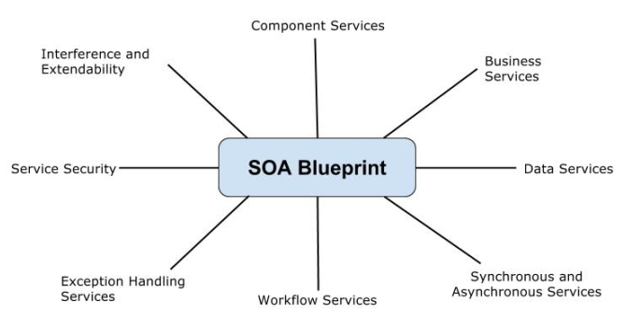

Considerations in SOA
There are some considerations must be covered in SOA:

Infrastructure
- Accessible of requirements
- Performance requirements
- Platform for system

Architecture
- Models of domain and service
- Organization of services
- Process of integrating the structure
- Quality of the service
- Message exchange patterns

Development
- Design guidelines for project development
- Required tools for project
- Validation and modification required things
- Handling errors
- Security for service access

Administration
- Managing and building
- Testing and deploying the project
- Location of data stored and registering the application
The following figure shows SOA blueprint with different classes:
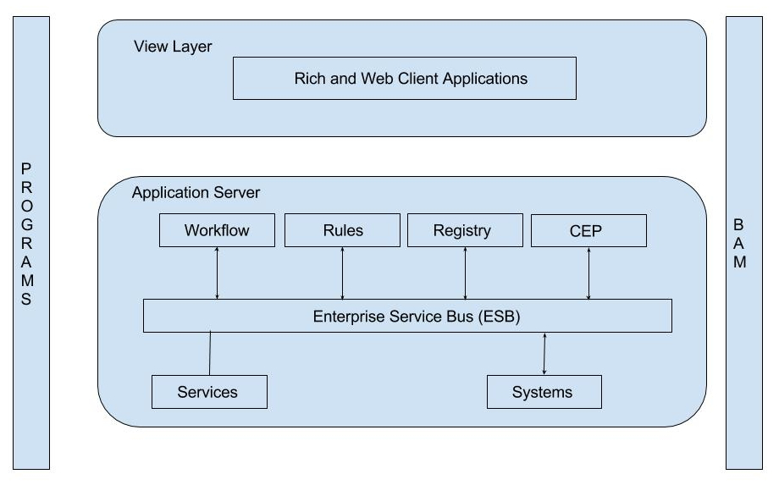
SOA contains the main functions of blueprint which are called as Programs andBAM.
Programs
The programs are associated with departmental issues which manages the development, monitoring and operation of the SOA. The programs include some areas such as managing services, operation and implementation of service domains, roles of SOA project, conversion between roles and tasks.
Business Activity Monitoring (BAM)
The business activity monitoring functionality can be used by the products to display the runtime details in the graphical system. The BAM products includes adapters or sensors which are used to access the data using the Java, PL/SQL and other languages.
View Layer
The view layer provides two types of applications; one is RichClient application and another one is WebClient application. The rich client application processes the data on the client side and contains some locally installed programs little network resources dependance. The web client is a client server side component which contains applications running on user's computer and connected to server.
Application Server
The application server includes some functionalities such as workflow, rules, registry, CEP, ESB, services and systems.
Workflow
The workflow is used when there is an interaction between human and implementation which is done through the XPDL (XML Process Definition Language). The BPEL (Business Process Execution Language) was used for runnable processes. When there is an upgrade in human interaction feature by using the WS-HumanTask and WS-BPEL4People specifications, results in blur boundaries of automated service calls.
Rules
The rules can be modified or changed commonly at run time when they are not incorporated in the system. You can define the rules which are based on the system or natural language, before becoming accessible by using the interfaces such as Java, Web service etc. The products contains rules like JBoss rules, WebSphere ILOG rules, Visual rules and Oracle business rules.
CEP
The CEP stands for Complex Event Processing which allows to browse event streams based on the certain pattern which can be uncorrelated in time or content. The Continuous Query Language (CQL) language contains SQL-style query language which attaches the elements for organizing the data streams to the SQL language constructs.
ESB
The ESB stands for Enterprise Service Bus which gives patterns that are liable for the tasks and ranges from routing to reachability, allow the interaction between message and protocol transformation and manages the SOA environment. The ESB is placed between service provider and consumer which is used for service virtualization. The services and systems are attached to the ESB.

SOA - Service Categories

Description
The service is a kind of operation which is well defined, self contained that performs a specific task.
The following figure shows SOA service categories:
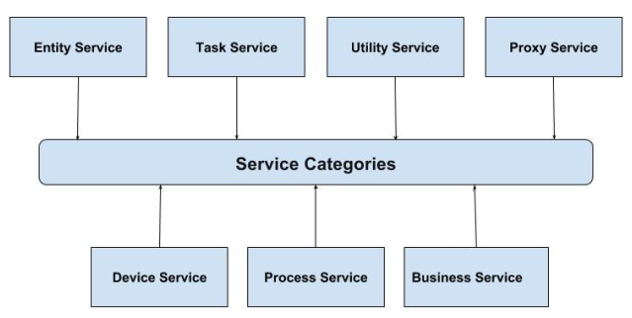
The service can be categorized into following ways:

Entity Service
The entity services include entities of customer such as purchase order, insurance policy, invoice of order, ordered date etc in which you can perform CRUD operations such as Create, Read, Delete and Update on the entities. These services provide information of the business process stored in the databases and handle the business entities.

Task Service
The task service adds the business logic to other services and due to its focus on business entity, it contains low amount of reusability. Task services provide operations on more than one entity such as customer purchase order, creating purchase order number, validating customer details etc. A service is called as task service when it needs to access the multiple entities.

Utility Service
The utility services are technology oriented services which are used to build larger and higher level services and provides other capabilities which are unrelated to the message transfer. The utility services provide reusable functions such as event logging, creating unique number and notification etc to the other functional domains. These services contain small, closely packed services which are used as building blocks in service oriented system.

Proxy Service
The proxy services contain the services which act as connection between members of the service oriented system and conflict subsystem. The device and process services lie under this type of services. Sometimes services which are defined under proxy services are called as gateway services.

Device Service
The device service is a kind of proxy service which is referred as hardware device and used to communicate between other services. The device service does not include the API which is not well suited with the service oriented system.

Process Service
The device service is also a kind of proxy service which acts as interpreter between application and service oriented system members. This service creates and arranges the application services to implement the business processes.

Business Service
Business services are also known as controller service which provides business functions for the completion of the business process and are flexible services that changes the business needs. These services develop the business applications that automate the business process such as managing the customer service, shipping the customer product etc.

SOA - Maturity

Description
The term SOA maturity defines the architectural guidelines for reaching the significant level of maturity in the information technology architecture enterprises and allows accessing the current state of SOA adoption of a company.
The figure below shows five levels of SOA Maturity:
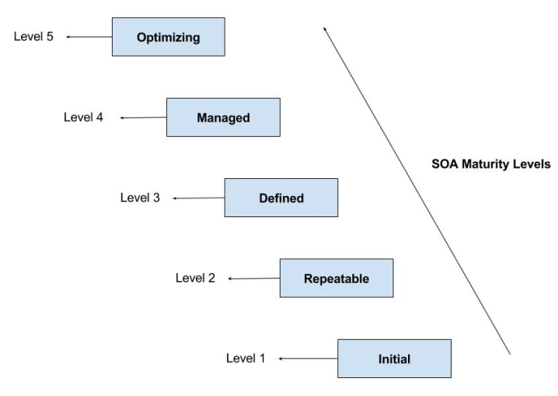Level 1: Initial
The initial level of SOA maturity includes the architecture and design phase of SOA which focus on delivering an individual project. The scope of this level includes:
- R&D experimentation
- Small SOA projects
- Implementation of portal and website
- Process of custom integration
- Number of services
Level 2: Repeatable`
In this level, you can use the reusable architected services which are flexible and can be used from one project to another. The scope of this level is providing multiple integrated applications that support some following factors:
- Low cost of delivery
- Low cost of maintenance
- Integration of database
- Integration of application
- Managing the performance
- Simple way of deployment
Level 3: Defined
In this level, the project team will be working on the creating architecture elements, providing guidelines to project members on the architecture and creates the technical components and frameworks which can be used across the project teams. At this level you can identify the service from the business level for the good quality of business arrangement. The scope of this level includes:
- Reuse of components
- Simple way of modification
- Changes the business process effectually
- Providing business process rules
Level 4: Managed
In this level, business services are managed and define the path to SOA. The project team's and enterprise architecture team's work together to specify the processes, technologies and components of an organization's SOA. You can measure end to end performance of the process in this level. The scope of this level includes:
- Using the business activity monitoring functionality to display the runtime details
- Specifying business process visibility
- Providing business process and service alerts
Level 5: Optimizing
In this level, the optimized business services react and respond automatically when you deliver the business processes during run time and include the clean identification of services. This level allows project team to reveal and consume services and also interchanges the services between customers, business partners and suppliers. The scope of this level includes:
- SOA will be optimized and associates with business
- Specifies the endpoint of an architecture enterprise
- Interacts with services from customers, partners and others

SOA - Enterprise Service Bus

Description
The Enterprise Service Bus (ESB) is a software architecture which connects all the services together over a bus like infrastructure. It acts as communication center in the SOA by allowing linking multiple systems, applications and data and connects multiple systems with no disruption.

ESB Basics
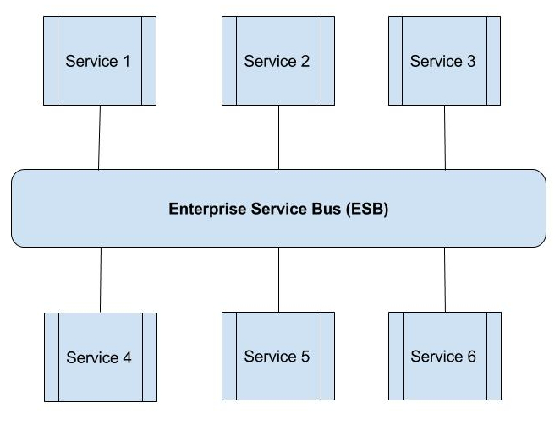
The above picture depicts the communication between software applications in a service-oriented architecture via ESB. Bus is a communication system that transfers data between computers and interconnects the hard disk drives, CD ROM, graphics adapters and other chips.

ESB as Transaction Manager
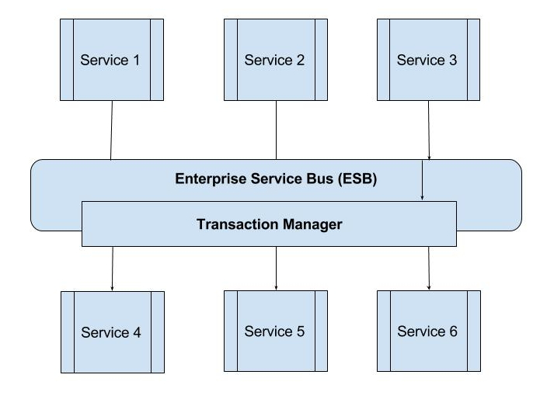
As shown in the above figure, the ESB can synchronize with transactions to communicate with multiple services. Instead of notifying the web applications to coordinate with transaction, the ESB can synchronize with transaction when multiple distributed applications get involved in a transaction.

ESB as Security Manager
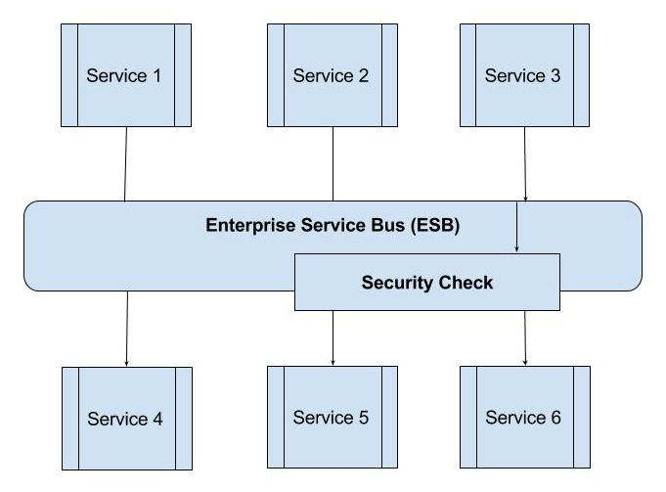
The authentication and authorization mechanisms are very important parts of security check which are incorporated under ESB. The ESB provides these security mechanisms to inter connect between the web applications.

ESB as Service Proxy
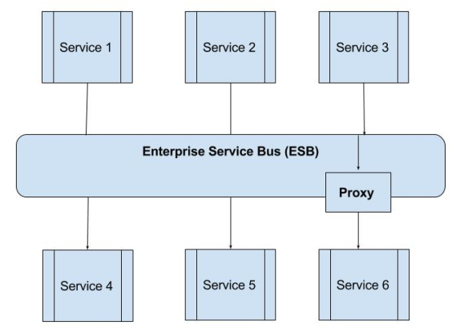
The SOA uses proxy which interprets the service calls between two different client service protocols. For instance, consider you need to access a service which can be accessible only through the Java's RMI (Remote Method Invocation) and this service can be accessed using the web service interface (SOAP). To resolve this, you can use the service proxy which accepts the SOAP calls and render them according to Java RMI service.

ESB as Gateway to the World
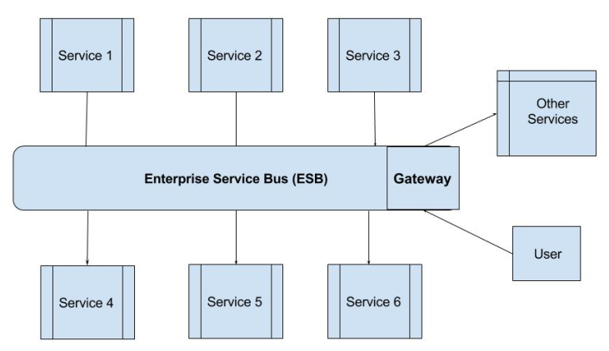
ESB uses the gateway (acts as entrance to another network) through which it can connect to the different services running in the other networks. The gateway manages the data communication which is routed internally or externally from the network. If user wants to access service of an outside network, then user passes data packet to the gateway, which then connect to the requested service destination.

SOA - Securing the SOA

Description
Most importantly, securing Service Oriented Architecture (SOA) is necessary to make sure that the services and applications run safely. For many reasons, including service exposures and loose coupling of components, securing SOA is essential because sometimes, exposed services becomes unprotected to attacks.

SOA Attacks
There are different types of attacks to which SOA environment may become unprotected, espcially if it was implemented using web service technology. Most of the people all around the world uses both SOA and web services which are rapidly developing areas, as a result they become more complex and open to attacks. On SAO and web services, most of the attacks takes place on the application service layer since web services communicate using XML and soap messages.
Following is a list of attacks in SOA:
- Injection Attacks: This attack occurs when no validation on the user input is performed and no separation is done between user input and application. For example, SQL injection, XML injection etc.
- Schema Poisoning Attack: This attack when occurs, modifies, replaces or even damages XML schemeas that provides the structure of XML documents.
- Denial Of Service Attacks (DoS): This attack when occurs, do not change the service or its behaviour but can block the use of the service.

Research Contributions
The main contributions are as follows:
- Providing an integrity for SOA that provides enough conditions for securing data integrity.
- Implementing testbed for SOA and setting environment of specification based IDS.
- Proposing intrusion detection system for SOA networks that are capable of detecting intrusions affecting behaviour of services.
- Recommending SOA testbed where SOAP messages can be monitored.

SOA - Service Composition

Description
Service composition is a collection of services where, many smaller services are combined together to a larger service.
Below diagram illustrates the service composition:
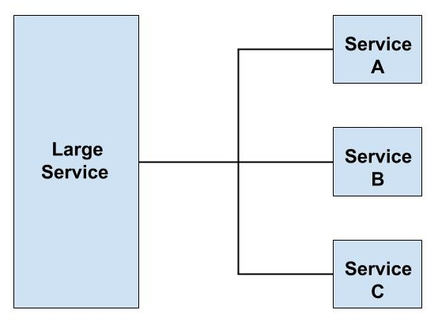
- In the above diagram, Service A, Service B and Service C are smaller services.
- Large service is composed by combining services A,B and C together.

Service Composition Performance
The services communicate with each other through a network just like component composition where inter-service communication is too slow as compared to inter-component communication taking place in the same application. The performance will be bad if the services communicate internally through ESB (Enterprise Service Bus) and larger services are decomposed to many smaller services.
Service compositions can be categorized into primitive and complex variations. Simple logic was implemented through point-to-point exchanges or primitive compositions in early service-oriented solutions. As the technology developed, complex compositions became more familiar.

SOA - SOA and User Interfaces

Description
Service-oriented applications mostly focus on the interaction between machines. However, in applications, the interaction between user and machine also plays an important role. A user can act as a service provider so that he can set SOA User Interface(SOAUI) design into an overall system design where the user interaction workflow is a part of system workflow.
The SOA User Interface follows MVC (Model View Controller) architectural pattern. SOA applications provide the model layer, and User Interfaces occupy the view layer.
The environments hosting components in the SOA approach are abstracted as containers that provides infrastructure services. From a User Interface view, below are the containers for hosting client-side UI components:
- Basic Web browser.
- Web browser augmented with Java™Script and dynamic HTML.
- IBM Workplace™ Client Technology™ -- the Eclipse-rich client plus native IBM WebSphere® Application Server client support.
By supporting technologies like servlets, JavaServer Pages (JSP), JSP Tags etc, the above containers can be expanded.
The user that interacts with a business process consists of initiating and awaiting the result of a process. It is important for a human to involve in a process cycle where processes rarely run completely and automatically. In such environment, WS-Human Task can fulfil this requirement.
A standardize API can be used to fill a mailbox with tasks that was defined for a workflow service. For example, during a process cycle, if input of addtional data is required, the process establishes correct actor and places the task in their mailbox through the task service. This process resumes its work in the background and the users recieve the entries in their mailbox by processing the pending tasks sequentailly.

SOA - Mobile Solutions

Description
Now day's mobiles have become high powered in today's economy and mobile web becoming cheaper and providing fast services to the user. The web based mobile solutions must communicate with backend in the enterprise environment.
The below diagram shows SOA based mobile application development:
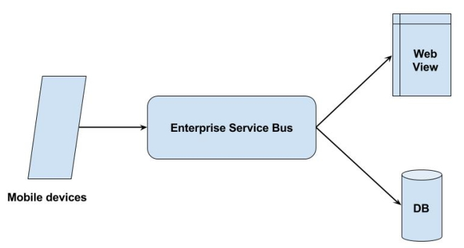
- Using the above picture, we can explain how the configuration of mobile solutions can be simplified by the service orientation.
- The object of the process is to read bar code of the items from the mobile phones.
- Next, user will fill the form and send it to the server. The message will not be send to the server directly, but it uses the interpreter calledEnterprise Service Bus (ESB) to process the data and send the message to appropriate server.
- In the last step, the message will get store into the database.

Mobile Part
It is an application runs on mobile phone which stores all the data in a local database and user can check the unset data and try to send them again.

Communication Middleware
The ESB acts as middleware between server and mobile phones which sends collected data from the mobile phones and processes the messages stored in the different databases. Middleware is a less customized part between mobile phones and server and results in the success of the system.

Server Side Part
The server side part frequently called as web view which provides the collected data which is retrieved from the database.
The above three parts (Mobile Part, Communication Middleware, Server Side Part) specifies that mobile solutions can be used in the systematic way by using the service oriented architectures.

SOA - Event Driven

Description
Event-driven architecture is a methodology used for designing and implementing applications where events transmit among decoupled software components and services.
In order to make the connections between the different events that do not appear to be clear, the event-driven SOA allows business users to monitor and analyze the events. SOA is capable of creating high-level business events from many low-level system events. Events are created by filtering real-time data with the details such as dependencies or casual relationships found by connecting other events.
An event-driven architecture is composed of Event Producers are the source of the event and it will know that the event has occurred and Event Consumers are the entity that needs to know the event has occurred.
- Event consumers typically subscribe to an intermediary event manager, whereas event producers publish to this manager.
- The event manager receives an event form the event producer and forwards that event to all the event consumers that are registered.
- The manager can also store the event and try to forward that event later, if the event consumer is unavailable. This event transmission method is known as store and forward in message-based systems.
This event-driven is organized around the concept of decoupled relationships between event producers and event consumers. An event consumer is only concerned that it will be invoked when the event has occurred, rather than caring where and why an event occurs. Enabling large number of creators and consumers to exchange status and response in real time is a good advantage of event-driven architecture.

SOA - MDM and SOA

Description
The MDM stands for Master Data Management which is a key component of Service Oriented Architecture (SOA) and simplifies the implementation of SOA with clean and consistent data to the enterprise. The basic intention of MDM is to provide reliable source for the master data.
The combination of SOA and MDM provides essential business value and describes how to get this value to the customers by working together. The Service Oriented Architecture is an architectural design which includes collection of services in a network which communicate with each other. Without MDM, the data available to business applications which is provided by the SOA will not be so accurate throughout an organization that leads to lower quality of data.

Levels between MDM and SOA
There are some levels which can be integrated between MDM and SOA:
- Connectors and modification
- Data structures and access methods
- Predefined MDM/SOA business process
- Predefined application and integration of master data
SOA improves standardization and reliable of data by adding value to SOA which is being integrated and consumed. MDM also provides stable clarity of data to SOA and technical foundation for master data use. SDM verifies quality of the data by providing data services to enterprise objects that SOA will consume.

Benefits of MDM
There are some benefits of MDM as listed below:
- It specifies the understanding and responsibility of master data entities
- It supplies the technique to make use of master data across the organization
- It is designed to provide accommodation and handle the changes
SOA allows reuse of components which makes easy and flexible to use them to support new processes. MDM provides service oriented concepts and components for maintaining and retrieval of data. The architecture concepts of SOA are integrated into MDM by using two views:
- MDM Business Service: It provides the reusable business service for maintaining and validating the data.
- MDM Information Service: It provides the reusable information service for using the business processes.
- SOA - Business Processes

Description
Business Process is a management authority that improves the performance of business and builds the operational solutions for SOA (service-oriented architecture). It adds business capabilities such as people, process, systems, technology etc which enables organization to be simpler, efficient and mechanisms can simplify and improved. In short, it is called as BPM (Business Process Management).

Why to use BPM?
The below points describes why to use the BPM in the business innovation:
- It implements and optimizes the business process.
- It is a powerful tool that keeps running operations optimally.
- It provides control over the process.
- It realizes the value quickly from efficient and flexible processes.
- It allows companies to process with good quality, less waste and less effort.

Benefits of BPM
The below points lists some of the benefits of BPM:
- It implements and optimizes the business process.
- It is a powerful tool that keeps running operations optimally.
- It decreases the cost and increases the business agility (changing the services to meet customer requirements).
- Implementing the business process provides increased efficiency.
- It makes the process more effective when process becomes more efficient.
- It specifies the higher productivity and faster process times.

Relationship of BPM and SOA
We all know processes run on services, so clearly service-oriented architecture and business process management belongs to each other.
S.N. | BPM | SOA
1 | It provides operational solutions which are main thing for business and process analysts. | It is an architectural style that is important to architects and engineers.
2 | It uses the reusable web services to delivers the enterprise capabilities. | It is also same as BPM that delivers the enterprise capabilities depending upon the reusable web services.
3 | It uses services to bring out their objectives. | It contains services which are implemented with business process can be altered quickly according to the business changes.
4 | It specifies as organization of business capabilities such as people, process, technology and data. | It describes as organization of technical capabilities such as activities, events, documents and data.
5 | It is a business rule that points to the improvement of operations. | It is an architectural style that points to systems of the enterprise.
BPM includes four types of components as listed below:
- Process Engine: It executes the business process applications and business rules.
- Business Analytics: It allows recognizing business issues, trends, appropriate moment with reports and dashboards.
- Content Management: It is used for storing electronic documents, images and other files.
- Collaboration Tools: It separates the communication barriers from different departments people by using discussion forums, message boards etc.
The software which is implemented with BPM provides more efficient and effective data. By using the real time updates of organization, you can take faster decisions and result will be more efficiency, effective and profit.

SOA - Cloud Computing

Description
Cloud computing is a model used for enabling convenient and usage-based network access to a configurable computing resources (eg. networks, servers etc) that can be provided and used rapidly.
- It provides a chance to business users to implement services with usage-based billing that is changed according to their requirements without need of consulting with IT department.
- It provides an abstraction layer between computing resources and its technical implementation details and sequentially enables computational resources to be used while avoiding efforts in infrastructure management.

Concepts in Cloud Computing
The below figure shows the SOA cloud computing along with the models:
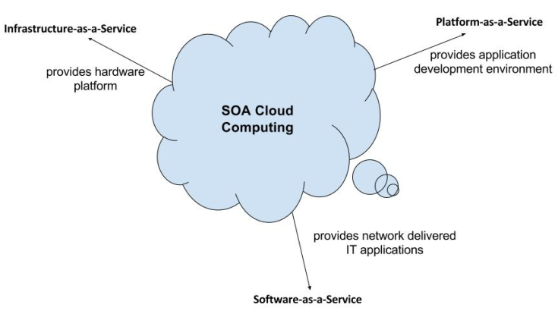
Below are the models that are differentiated on the horizontal scaling basis in cloud computing:
- Infrastructure-as-a-Service (IaaS): It provides a hardware platform as a service.
- Platform-as-a-Service (PaaS): It provides end-users an application development environment delivered over the internet.
- Software-as-a-Service (SaaS): It provides end-users a standardized, network-delivered IT applications.
The distinctions are made according to availability and the location of installation in the deployment models. Private clouds are internal company services whereas public clouds are the services that are available to the public on internet.
In the large companies where IT plays an important role, internal company cloud solutions are often built in their own data centers. Small and medium companies often use public cloud services. Cloud Computing provides a very flexible and scalable platform through processing external services and also has the ability to connect with customers, suppliers etc.

SOAP Tutorial
SOAP is an open-standard, XML-based messaging protocol for exchanging information among computers. This is a brief tutorial that introduces the readers to the fundamentals of SOAP before moving on to explain its various elements, encoding, and how SOAP is transported.

What is SOAP?
SOAP is an acronym for Simple Object Access Protocol. It is an XML-based messaging protocol for exchanging information among computers. SOAP is an application of the XML specification.

Points to Note
Below mentioned are some important point which the user should take note of. These points briefly describes the nature of SOAP −
- SOAP is a communication protocol designed to communicate via Internet.
- SOAP can extend HTTP for XML messaging.
- SOAP provides data transport for Web services.
- SOAP can exchange complete documents or call a remote procedure.
- SOAP can be used for broadcasting a message.
- SOAP is platform- and language-independent.
- SOAP is the XML way of defining what information is sent and how.
- SOAP enables client applications to easily connect to remote services and invoke remote methods.
Although SOAP can be used in a variety of messaging systems and can be delivered via a variety of transport protocols, the initial focus of SOAP is remote procedure calls transported via HTTP.
Other frameworks including CORBA, DCOM, and Java RMI provide similar functionality to SOAP, but SOAP messages are written entirely in XML and are therefore uniquely platform- and language-independent.

SOAP - Message Structure
A SOAP message is an ordinary XML document containing the following elements −
- Envelope − Defines the start and the end of the message. It is a mandatory element.
- Header − Contains any optional attributes of the message used in processing the message, either at an intermediary point or at the ultimate end-point. It is an optional element.
- Body − Contains the XML data comprising the message being sent. It is a mandatory element.
- Fault − An optional Fault element that provides information about errors that occur while processing the message.
NOTE − All these specifications are subject to change. So keep updating yourself with the latest specifications available on the W3 website.

SOAP Message Structure
The following block depicts the general structure of a SOAP message −
<?xml version="1.0"?>
<SOAP-ENV:Envelope xmlns:SOAP-ENV="http://www.w3.org/2001/12/soap-envelope" SOAP-ENV:encodingStyle="http://www.w3.org/2001/12/soap-encoding">

<SOAP-ENV:Header>
...
...
</SOAP-ENV:Header>

<SOAP-ENV:Body>
...
...
<SOAP-ENV:Fault>
...
...
</SOAP-ENV:Fault>
...
</SOAP-ENV:Body>

</SOAP_ENV:Envelope>

SOAP - Envelope Element
The SOAP envelope indicates the start and the end of the message so that the receiver knows when an entire message has been received. The SOAP envelope solves the problem of knowing when you are done receiving a message and are ready to process it. The SOAP envelope is therefore basically a packaging mechanism.

Points to Note
Below mentioned are some important points about SOAP envelope element −
- Every SOAP message has a root Envelope element.
- Envelope is a mandatory part of SOAP message.
- Every Envelope element must contain exactly one Body element.
- If an Envelope contains a Header element, it must contain no more than one, and it must appear as the first child of the Envelope, before the Body.
- The envelope changes when SOAP versions change.
- The SOAP envelope is specified using the ENV namespace prefix and the Envelope element.
- The optional SOAP encoding is also specified using a namespace name and the optional encodingStyle element, which could also point to an encoding style other than the SOAP one.
- A v1.1-compliant SOAP processor generates a fault upon receiving a message containing the v1.2 envelope namespace.
- A v1.2-compliant SOAP processor generates a VersionMismatch fault if it receives a message that does not include the v1.2 envelope namespace.

v1.2-Compliant SOAP Message
Given below is an example of v1.2-compliant SOAP message.
<?xml version="1.0"?>

<SOAP-ENV:Envelope xmlns:SOAP-ENV="http://www.w3.org/2001/12/soap-envelope" SOAP-ENV:encodingStyle=" http://www.w3.org/2001/12/soap-encoding">
...
Message information goes here
...
</SOAP-ENV:Envelope>

SOAP with HTTP POST
The following example illustrates the use of a SOAP message within an HTTP POST operation, which sends the message to the server. It shows the namespaces for the envelope schema definition and for the schema definition of the encoding rules. The OrderEntry reference in the HTTP header is the name of the program to be invoked at the tutorialspoint.com website.
POST /OrderEntry HTTP/1.1
Host: www.tutorialspoint.com
Content-Type: application/soap; charset="utf-8"
Content-Length: nnnn
<?xml version="1.0"?>

<SOAP-ENV:Envelope xmlns:SOAP-ENV="http://www.w3.org/2001/12/soap-envelope" SOAP-ENV:encodingStyle=" http://www.w3.org/2001/12/soap-encoding">
...
Message information goes here
...
</SOAP-ENV:Envelope>
NOTE − The HTTP binding specifies the location of the service.

SOAP - Header Element

The optional Header element offers a flexible framework for specifying additional application-level requirements. For example, the Header element can be used to specify a digital signature for password-protected services. Likewise, it can be used to specify an account number for pay-per-use SOAP services.

Points to Note
Below mentioned are few important points about SOAP header element to take note of −
- It is an optional part of a SOAP message.
- Header elements can occur multiple times.
- Headers are intended to add new features and functionality.
- The SOAP header contains header entries defined in a namespace.
- The header is encoded as the first immediate child element of the SOAP envelope.
- When multiple headers are defined, all immediate child elements of the SOAP header are interpreted as SOAP header blocks.

SOAP Header Attributes
A SOAP Header can have the following two attributes −

Actor attribute
The SOAP protocol defines a message path as a list of SOAP service nodes. Each of these intermediate nodes can perform some processing and then forward the message to the next node in the chain. By setting the Actor attribute, the client can specify the recipient of the SOAP header.

MustUnderstand attribute
It indicates whether a Header element is optional or mandatory. If set to true, the recipient must understand and process the Header attribute according to its defined semantics, or return a fault.
The following example shows how to use a Header in a SOAP message.
<?xml version="1.0"?>

<SOAP-ENV:Envelope xmlns:SOAP-ENV=" http://www.w3.org/2001/12/soap-envelope" SOAP-ENV:encodingStyle=" http://www.w3.org/2001/12/soap-encoding">

<SOAP-ENV:Header>
<t:Transaction xmlns:t="http://www.tutorialspoint.com/transaction/" SOAP-ENV:mustUnderstand="true">5</t:Transaction>
</SOAP-ENV:Header>
...
...
</SOAP-ENV:Envelope>

SOAP - Body Element

The SOAP body is a mandatory element that contains the application-defined XML data being exchanged in the SOAP message. The body must be contained within the envelope and must follow any headers that might be defined for the message.
The body is defined as a child element of the envelope, and the semantics for the body are defined in the associated SOAP schema.
The body contains mandatory information intended for the ultimate receiver of the message. For example −
<?xml version="1.0"?>

<SOAP-ENV:Envelope>
........

<SOAP-ENV:Body>
<m:GetQuotation xmlns:m="http://www.tp.com/Quotation">
<m:Item>Computers</m:Item>
</m:GetQuotation>
</SOAP-ENV:Body>

</SOAP-ENV:Envelope>
The example above requests a quotation of computer sets. Note that the m:GetQuotation and the Item elements above are application-specific elements. They are not a part of the SOAP standard.
Here is the response to the above query −
<?xml version="1.0"?>

<SOAP-ENV:Envelope>
........

<SOAP-ENV:Body>
<m:GetQuotationResponse xmlns:m="http://www.tp.com/Quotation">
<m:Quotation>This is Qutation</m:Quotation>
</m:GetQuotationResponse>
</SOAP-ENV:Body>

</SOAP-ENV:Envelope>
Normally, the application also defines a schema to contain semantics associated with the request and response elements.
The Quotation service might be implemented using an EJB running in an application server; if so, the SOAP processor would be responsible for mapping the body information as parameters into and out of the EJB implementation of the GetQuotationResponse service. The SOAP processor could also be mapping the body information to a .NET object, a CORBA object, a COBOL program, and so on.

SOAP - Fault Element

If an error occurs during processing, the response to a SOAP message is a SOAP fault element in the body of the message, and the fault is returned to the sender of the SOAP message.
The SOAP fault mechanism returns specific information about the error, including a predefined code, a description, and the address of the SOAP processor that generated the fault.

Points to Note
Below mentioned are few important points about SOAP fault element to take note of −
- A SOAP message can carry only one fault block.
- Fault is an optional part of a SOAP message.
- For HTTP binding, a successful response is linked to the 200 to 299 range of status codes.
- SOAP Fault is linked to the 500 to 599 range of status codes.

Sub-elements of Fault
The SOAP Fault has the following sub elements −
Sub-element | Description
<faultCode> | It is a text code used to indicate a class of errors. See the next Table for a listing of predefined fault codes.
<faultString> | It is a text message explaining the error.
<faultActor> | It is a text string indicating who caused the fault. It is useful if the SOAP message travels through several nodes in the SOAP message path, and the client needs to know which node caused the error. A node that does not act as the ultimate destination must include a faultActor element.
<detail> | It is an element used to carry application-specific error messages. The detail element can contain child elements called detail entries.

SOAP Fault Codes
The faultCode values defined below must be used in the faultcode element while describing faults.
Error | Description
SOAP-ENV:VersionMismatch | Found an invalid namespace for the SOAP Envelope element.
SOAP-ENV:MustUnderstand | An immediate child element of the Header element, with the mustUnderstand attribute set to "1", was not understood.
SOAP-ENV:Client | The message was incorrectly formed or contained incorrect information.
SOAP-ENV:Server | There was a problem with the server, so the message could not proceed.

SOAP Fault Example
The following code is a sample Fault. The client has requested a method namedValidateCreditCard, but the service does not support such a method. This represents a client request error, and the server returns the following SOAP response −
<?xml version='1.0' encoding='UTF-8'?>

<SOAP-ENV:Envelope xmlns:SOAP-ENV="http://schemas.xmlsoap.org/soap/envelope/" xmlns:xsi="http://www.w3.org/1999/XMLSchema-instance" xmlns:xsd="http://www.w3.org/1999/XMLSchema">

<SOAP-ENV:Body>

<SOAP-ENV:Fault>
<faultcode xsi:type="xsd:string">SOAP-ENV:Client</faultcode>

<faultstring xsi:type="xsd:string">
Failed to locate method (ValidateCreditCard) in class (examplesCreditCard) at /usr/local/ActivePerl-5.6/lib/site_perl/5.6.0/SOAP/Lite.pm line 1555.
</faultstring>

</SOAP-ENV:Fault>
</SOAP-ENV:Body>

</SOAP-ENV:Envelope>

SOAP - Encoding
SOAP includes a built-in set of rules for encoding data types. It enables the SOAP message to indicate specific data types, such as integers, floats, doubles, or arrays.
- SOAP data types are divided into two broad categories − scalar types and compound types.
- Scalar types contain exactly one value such as a last name, price, or product description.
- Compound types contain multiple values such as a purchase order or a list of stock quotes.
- Compound types are further subdivided into arrays and structs.
- The encoding style for a SOAP message is set via the SOAP-ENV:encodingStyle attribute.
- To use SOAP 1.1 encoding, use the valuehttp://schemas.xmlsoap.org/soap/encoding/
- To use SOAP 1.2 encoding, use the valuehttp://www.w3.org/2001/12/soap-encoding
- Latest SOAP specification adopts all the built-in types defined by XML Schema. Still, SOAP maintains its own convention for defining constructs not standardized by XML Schema, such as arrays and references.

Scalar Types
For scalar types, SOAP adopts all the built-in simple types specified by the XML Schema specification. This includes strings, floats, doubles, and integers.
The following table lists the main simple types, excerpted from the XML Schema Part 0 − Primer http://www.w3.org/TR/2000/WD-xmlschema-0-20000407/

Simple Types Built-In to XML Schema
Simple Type | Example(s)
string | Confirm this is electric.
boolean | true, false, 1, 0.
float | -INF, -1E4, -0, 0, 12.78E-2, 12, INF, NaN.
double | -INF, -1E4, -0, 0, 12.78E-2, 12, INF, NaN.
decimal | -1.23, 0, 123.4, 1000.00.
binary | 100010
integer | -126789, -1, 0, 1, 126789.
nonPositiveInteger | -126789, -1, 0.
negativeInteger | -126789, -1.
long | -1, 12678967543233
int | -1, 126789675
short | -1, 12678
byte | -1, 126
nonNegativeInteger | 0, 1, 126789
unsignedLong | 0, 12678967543233
unsignedInt | 0, 1267896754
unsignedShort | 0, 12678
unsignedByte | 0, 126
positiveInteger | 1, 126789.
date | 1999-05-31, ---05.
time | 13:20:00.000, 13:20:00.000-05:00
For example, here is a SOAP response with a double data type −
<?xml version='1.0' encoding='UTF-8'?>

<SOAP-ENV:Envelope xmlns:SOAP-ENV="http://www.w3.org/2001/12/soap-envelope" xmlns:xsi="http://www.w3.org/2001/XMLSchema-instance" xmlns:xsd="http://www.w3.org/2001/XMLSchema">

<SOAP-ENV:Body>
<ns1:getPriceResponse xmlns:ns1="urn:examples:priceservice" SOAP-ENV:encodingStyle="http://www.w3.org/2001/12/soap-encoding">

<return xsi:type="xsd:double">54.99</return>

</ns1:getPriceResponse>
</SOAP-ENV:Body>

</SOAP-ENV:Envelope>

Compound Types
SOAP arrays have a very specific set of rules, which require that you specify both the element type and array size. SOAP also supports multidimensional arrays, but not all SOAP implementations support multidimensional functionality.
To create an array, you must specify it as an xsi:type of array. The array must also include an arrayType attribute. This attribute is required to specify the data type for the contained elements and the dimension(s) of the array.
For example, the following attribute specifies an array of 10 double values −
arrayType = "xsd:double[10]"
In contrast, the following attribute specifies a two-dimensional array of strings −
arrayType = "xsd:string[5,5]"
Here is a sample SOAP response with an array of double values −
<?xml version='1.0' encoding='UTF-8'?>
<SOAP-ENV:Envelope xmlns:SOAP-ENV="http://www.w3.org/2001/12/soap-envelope" xmlns:xsi="http://www.w3.org/2001/XMLSchema-instance" xmlns:xsd="http://www.w3.org/2001/XMLSchema">

<SOAP-ENV:Body>
<ns1:getPriceListResponse xmlns:ns1="urn:examples:pricelistservice" SOAP-ENV:encodingStyle="http://www.w3.org/2001/12/soap-encoding">

<return xmlns:ns2="http://www.w3.org/2001/09/soap-encoding" xsi:type="ns2:Array" ns2:arrayType="xsd:double[2]">
<item xsi:type="xsd:double">54.99</item>
<item xsi:type="xsd:double">19.99</item>
</return>

</ns1:getPriceListResponse>
</SOAP-ENV:Body>
</SOAP-ENV:Envelope>
Structs contain multiple values, but each element is specified with a unique accessor element. For example, consider an item within a product catalog. In this case, the struct might contain a product SKU, product name, description, and price. Here is how such a struct would be represented in a SOAP message −
<?xml version='1.0' encoding='UTF-8'?>
<SOAP-ENV:Envelope xmlns:SOAP-ENV="http://www.w3.org/2001/12/soap-envelope" xmlns:xsi="http://www.w3.org/2001/XMLSchema-instance" xmlns:xsd="http://www.w3.org/2001/XMLSchema">

<SOAP-ENV:Body>
<ns1:getProductResponse xmlns:ns1="urn:examples:productservice" SOAP-ENV:encodingStyle="http://www.w3.org/2001/12/soap-encoding">

<return xmlns:ns2="urn:examples" xsi:type="ns2:product">
<name xsi:type="xsd:string">Red Hat Linux</name>
<price xsi:type="xsd:double">54.99</price>

<description xsi:type="xsd:string">
Red Hat Linux Operating System
</description>
<SKU xsi:type="xsd:string">A358185</SKU>
</return>

</ns1:getProductResponse>
</SOAP-ENV:Body>
</SOAP-ENV:Envelope>
NOTE − Please take care of proper indentation while you write your SOAP code. Each element in a struct is specified with a unique accessor name. For example, the message above includes four accessor elements − name, price, description, and SKU. Each element can have its own data type. For example, name is specified as a string, whereas price is specified as double.

SOAP - Transport

SOAP is not tied to any transport protocol. SOAP can be transported via SMTP, FTP, IBM's MQSeries, or Microsoft Message Queuing (MSMQ).
SOAP specification includes details on HTTP only. HTTP remains the most popular SOAP transport protocol.

SOAP via HTTP
Quite logically, SOAP requests are sent via an HTTP request and SOAP responses are returned within the content of the HTTP response. While SOAP requests can be sent via an HTTP GET, the specification includes details on HTTP POST only.
Additionally, both HTTP requests and responses are required to set their content type to text/xml.
The SOAP specification mandates that the client must provide a SOAPAction header, but the actual value of the SOAPAction header is dependent on the SOAP server implementation.
For example, to access the AltaVista BabelFish Translation service, hosted by XMethods, you must specify the following as a SOAPAction header.
urn:xmethodsBabelFish#BabelFish
Even if the server does not require a full SOAPAction header, the client must specify an empty string ("") or a null value. For example −
SOAPAction: ""
SOAPAction:
Here is a sample request sent via HTTP to the XMethods Babelfish Translation service −
POST /perl/soaplite.cgi HTTP/1.0
Host: services.xmethods.com
Content-Type: text/xml; charset=utf-8
Content-Length: 538
SOAPAction: "urn:xmethodsBabelFish#BabelFish"

<?xml version='1.0' encoding='UTF-8'?>
<SOAP-ENV:Envelope xmlns:SOAP-ENV="http://schemas.xmlsoap.org/soap/envelope/" xmlns:xsi="http://www.w3.org/1999/XMLSchema-instance" xmlns:xsd="http://www.w3.org/1999/XMLSchema">

<SOAP-ENV:Body>

<ns1:BabelFish xmlns:ns1="urn:xmethodsBabelFish" SOAP-ENV:encodingStyle="http://schemas.xmlsoap.org/soap/encoding/">
<translationmode xsi:type="xsd:string">en_fr</translationmode>
<sourcedata xsi:type="xsd:string">Hello, world!</sourcedata>
</ns1:BabelFish>

</SOAP-ENV:Body>

</SOAP-ENV:Envelope>
Note the content type and the SOAPAction header. Also note that the BabelFish method requires two String parameters. The translation mode en_fr translates from English to French.
Here is the response from XMethods −
HTTP/1.1 200 OK
Date: Sat, 09 Jun 2001 15:01:55 GMT
Server: Apache/1.3.14 (Unix) tomcat/1.0 PHP/4.0.1pl2
SOAPServer: SOAP::Lite/Perl/0.50
Cache-Control: s-maxage=60, proxy-revalidate
Content-Length: 539
Content-Type: text/xml

<?xml version="1.0" encoding="UTF-8"?>
<SOAP-ENV:Envelope xmlns:SOAP-ENC="http://schemas.xmlsoap.org/soap/encoding/" SOAP-ENV:encodingStyle="http://schemas.xmlsoap.org/soap/encoding/" xmlns:xsi="http://www.w3.org/1999/XMLSchema-instance" xmlns:SOAP-ENV="http://schemas.xmlsoap.org/soap/envelope/" xmlns:xsd="http://www.w3.org/1999/XMLSchema">
<SOAP-ENV:Body>

<namesp1:BabelFishResponse xmlns:namesp1="urn:xmethodsBabelFish">
<return xsi:type="xsd:string">Bonjour, monde!</return>
</namesp1:BabelFishResponse>

</SOAP-ENV:Body>

</SOAP-ENV:Envelope>
SOAP responses delivered via HTTP are required to follow the same HTTP status codes. For example, a status code of 200 OK indicates a successful response. A status code of 500 Internal Server Error indicates that there is a server error and that the SOAP response includes a Fault element.

SOAP - Examples
In the example below, a GetQuotation request is sent to a SOAP Server over HTTP. The request has a QuotationName parameter, and a Quotation will be returned in the response.
The namespace for the function is defined in http://www.xyz.org/quotationaddress.
Here is the SOAP request −
POST /Quotation HTTP/1.0
Host: www.xyz.org
Content-Type: text/xml; charset=utf-8
Content-Length: nnn

<?xml version="1.0"?>
<SOAP-ENV:Envelope xmlns:SOAP-ENV="http://www.w3.org/2001/12/soap-envelope" SOAP-ENV:encodingStyle="http://www.w3.org/2001/12/soap-encoding" >

<SOAP-ENV:Body xmlns:m="http://www.xyz.org/quotations" >

<m:GetQuotation>
<m:QuotationsName>MiscroSoft</m:QuotationsName>
</m:GetQuotation>

</SOAP-ENV:Body>

</SOAP-ENV:Envelope>
A corresponding SOAP response looks like −
HTTP/1.0 200 OK
Content-Type: text/xml; charset=utf-8
Content-Length: nnn

<?xml version="1.0"?>
<SOAP-ENV:Envelope xmlns:SOAP-ENV="http://www.w3.org/2001/12/soap-envelope" SOAP-ENV:encodingStyle="http://www.w3.org/2001/12/soap-encoding" >

<SOAP-ENV:Body xmlns:m="http://www.xyz.org/quotation" >

<m:GetQuotationResponse>
<m:Quotation>Here is the quotation</m:Quotation>
</m:GetQuotationResponse>

</SOAP-ENV:Body>

</SOAP-ENV:Envelope>

SOAP - Standards

SOAP 1.1 was originally submitted to the W3C in May 2000. Official submitters included large companies such as Microsoft, IBM, and Ariba, and smaller companies such as UserLand Software and DevelopMentor.
In July 2001, the XML Protocol Working Group released a "working draft" of SOAP 1.2. Within the W3C, this document is officially a work in progress, meaning that the document is likely to be updated many times before it is finalized.
SOAP Version 1.1 is available online at http://www.w3.org/TR/SOAP/
The working draft of SOAP Version 1.2 is available athttp://www.w3.org/TR/soap12/
Note that the W3C also hosts a submission for "SOAP Messages with Attachments", which separates from the core SOAP specification. This specification enables SOAP messages to include binary attachments such as images and sound files. For full details, see the W3C Note athttp://www.w3.org/TR/SOAP-attachments.

UDDI Tutorial

UDDI is an XML-based standard for describing, publishing, and finding Web services. In this tutorial, you will learn what is UDDI and why and how to use it.
UDDI is an XML-based standard for describing, publishing, and finding web services.
- UDDI stands for Universal Description, Discovery, and Integration.
- UDDI is a specification for a distributed registry of web services.
- UDDI is a platform-independent, open framework.
- UDDI can communicate via SOAP, CORBA, Java RMI Protocol.
- UDDI uses Web Service Definition Language(WSDL) to describe interfaces to web services.
- UDDI is seen with SOAP and WSDL as one of the three foundation standards of web services.
- UDDI is an open industry initiative, enabling businesses to discover each other and define how they interact over the Internet.
UDDI has two sections:
- A registry of all web service's metadata, including a pointer to the WSDL description of a service.
- A set of WSDL port type definitions for manipulating and searching that registry.

History of UDDI
- UDDI 1.0 was originally announced by Microsoft, IBM, and Ariba in September 2000.
- Since the initial announcement, the UDDI initiative has grown to include more than 300 companies including Dell, Fujitsu, HP, Hitachi, IBM, Intel, Microsoft, Oracle, SAP, and Sun.
- In May 2001, Microsoft and IBM launched the first UDDI operator sites and turned the UDDI registry live.
- In June 2001, UDDI announced Version 2.0.
- As the time of writing this tutorial, Microsoft and IBM sites had implemented the 1.0 specification and were planning 2.0 support in the near future.
- Currently UDDI is sponsored by OASIS.

Partner Interface Processes
Partner Interface Processes (PIPs) are XML based interfaces that enable two trading partners to exchange data. Dozens of PIPs already exist. Some of them are listed here:
- PIP2A2 : Enables a partner to query another for product information.
- PIP3A2 : Enables a partner to query the price and availability of specific products.
- PIP3A4 : Enables a partner to submit an electronic purchase order and receive acknowledgment of the order.
- PIP3A3 : Enables a partner to transfer the contents of an electronic shopping cart.
- PIP3B4 : Enables a partner to query the status of a specific shipment.

Private UDDI Registries
As an alternative to using the public federated network of UDDI registries available on the Internet, companies or industry groups may choose to implement their own private UDDI registries.
These exclusive services are designed for the sole purpose of allowing members of the company or of the industry group to share and advertise services amongst themselves.
Regardless of whether the UDDI registry is a part of the global federated network or a privately owned and operated registry, the one thing that ties them all together is a common web services API for publishing and locating businesses and services advertised within the UDDI registry.

UDDI - Elements

A business or a company can register three types of information into a UDDI registry. This information is contained in three elements of UDDI.
These three elements are:
- White Pages,
- Yellow Pages, and
- Green Pages.

White Pages
White pages contain:
- Basic information about the company and its business.
- Basic contact information including business name, address, contact phone number, etc.
- A Unique identifiers for the company tax IDs. This information allows others to discover your web service based upon your business identification.

Yellow Pages
- Yellow pages contain more details about the company. They include descriptions of the kind of electronic capabilities the company can offer to anyone who wants to do business with it.
- Yellow pages uses commonly accepted industrial categorization schemes, industry codes, product codes, business identification codes and the like to make it easier for companies to search through the listings and find exactly what they want.

Green Pages
Green pages contains technical information about a web service. A green page allows someone to bind to a Web service after it's been found. It includes:
- The various interfaces
- The URL locations
- Discovery information and similar data required to find and run the Web service.
NOTE : UDDI is not restricted to describing web services based on SOAP. Rather, UDDI can be used to describe any service, from a single webpage or email address all the way up to SOAP, CORBA, and Java RMI services.

UDDI - Technical Architecture
The UDDI technical architecture consists of three parts:

UDDI Data Model
UDDI Data Model is an XML Schema for describing businesses and web services. The data model is described in detail in the "UDDI Data Model" chapter.

UDDI API Specification
It is a specification of API for searching and publishing UDDI data.

UDDI Cloud Services
These are operator sites that provide implementations of the UDDI specification and synchronize all data on a scheduled basis.
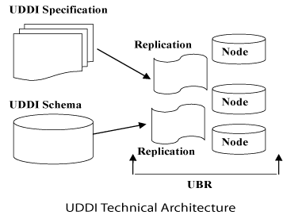
The UDDI Business Registry (UBR), also known as the Public Cloud, is a conceptually single system built from multiple nodes having their data synchronized through replication.
The current cloud services provide a logically centralized, but physically distributed, directory. It means the data submitted to one root node will automatically be replicated across all the other root nodes. Currently, data replication occurs every 24 hours.
UDDI cloud services are currently provided by Microsoft and IBM. Ariba had originally planned to offer an operator as well, but has since backed away from the commitment. Additional operators from other companies, including Hewlett-Packard, are planned for the near future.
It is also possible to set up private UDDI registries. For example, a large company may set up its own private UDDI registry for registering all internal web services. As these registries are not automatically synchronized with the root UDDI nodes, they are not considered as a part of the UDDI cloud.

UDDI - Data Model
UDDI includes an XML Schema that describes the following data structures:
- businessEntity
- businessService
- bindingTemplate
- tModel
- publisherAssertion

businessEntity Data Structure
The business entity structure represents the provider of web services. Within the UDDI registry, this structure contains information about the company itself, including contact information, industry categories, business identifiers, and a list of services provided.
Here is an example of a fictitious business's UDDI registry entry:
<businessEntity businessKey="uuid:C0E6D5A8-C446-4f01-99DA-70E212685A40"
operator="http://www.ibm.com" authorizedName="John Doe">
<name>Acme Company</name>
<description>
We create cool Web services
</description>

<contacts>
<contact useType="general info">
<description>General Information</description>
<personName>John Doe</personName>
<phone>(123) 123-1234</phone>
<email>jdoe@acme.com</email>
</contact>
</contacts>

<businessServices>
...
</businessServices>
<identifierBag>
<keyedReference tModelKey="UUID:8609C81E-EE1F-4D5A-B202-3EB13AD01823" name="D-U-N-S" value="123456789" />
</identifierBag>

<categoryBag>
<keyedReference tModelKey="UUID:C0B9FE13-179F-413D-8A5B-5004DB8E5BB2" name="NAICS" value="111336" />
</categoryBag>
</businessEntity>

businessService Data Structure
The business service structure represents an individual web service provided by the business entity. Its description includes information on how to bind to the web service, what type of web service it is, and what taxonomical categories it belongs to.
Here is an example of a business service structure for the Hello World web service.
<businessService serviceKey="uuid:D6F1B765-BDB3-4837-828D-8284301E5A2A"
businessKey="uuid:C0E6D5A8-C446-4f01-99DA-70E212685A40">

<name>Hello World Web Service</name>
<description>A friendly Web service</description>
<bindingTemplates>
...
</bindingTemplates>
<categoryBag />
</businessService
Notice the use of the Universally Unique Identifiers (UUIDs) in the businessKeyand serviceKey attributes. Every business entity and business service is uniquely identified in all the UDDI registries through the UUID assigned by the registry when the information is first entered.

bindingTemplate Data Structure
Binding templates are the technical descriptions of the web services represented by the business service structure. A single business service may have multiple binding templates. The binding template represents the actual implementation of the web service.
Here is an example of a binding template for Hello World.
<bindingTemplate serviceKey="uuid:D6F1B765-BDB3-4837-828D-8284301E5A2A"
bindingKey="uuid:C0E6D5A8-C446-4f01-99DA-70E212685A40">

<description>Hello World SOAP Binding</description>
<accessPoint URLType="http">http://localhost:8080</accessPoint>
<tModelInstanceDetails>
<tModelInstanceInfo tModelKey="uuid:EB1B645F-CF2F-491f-811A-4868705F5904">
<instanceDetails>
<overviewDoc>
<description>
references the description of the WSDL service definition
</description>

<overviewURL>
http://localhost/helloworld.wsdl
</overviewURL>
</overviewDoc>
</instanceDetails>
</tModelInstanceInfo>
</tModelInstanceDetails>
</bindingTemplate>
As a business service may have multiple binding templates, the service may specify different implementations of the same service, each bound to a different set of protocols or a different network address.

tModel Data Structure
tModel is the last core data type, but potentially the most difficult to grasp. tModel stands for technical model.
tModel is a way of describing the various business, service, and template structures stored within the UDDI registry. Any abstract concept can be registered within the UDDI as a tModel. For instance, if you define a new WSDL port type, you can define a tModel that represents that port type within the UDDI. Then, you can specify that a given business service implements that port type by associating the tModel with one of that business service's binding templates.
Here is an example of a tModel representing the Hello World Interface port type.
<tModel tModelKey="uuid:xyz987..." operator="http://www.ibm.com" authorizedName="John Doe">
<name>HelloWorldInterface Port Type</name>
<description>
An interface for a friendly Web service
</description>

<overviewDoc>
<overviewURL>
http://localhost/helloworld.wsdl
</overviewURL>
</overviewDoc>
</tModel>

publisherAssertion Data Structure
This is a relationship structure putting into association two or more businessEntity structures according to a specific type of relationship, such as subsidiary or department.
The publisherAssertion structure consists of the three elements: fromKey (the first businessKey), toKey (the second businessKey), and keyedReference.
The keyedReference designates the asserted relationship type in terms of a keyName keyValue pair within a tModel, uniquely referenced by a tModelKey.
<element name="publisherAssertion" type="uddi:publisherAssertion" />
<complexType name="publisherAssertion">
<sequence>
<element ref="uddi:fromKey" />
<element ref="uddi:toKey" />
<element ref="uddi:keyedReference" />
</sequence>
</complexType>

UDDI - Interfaces
A registry is of no use without some way to access it. The UDDI standard version 2.0 specifies two interfaces for service consumers and service providers to interact with the registry.
Service consumers use Inquiry Interface to find a service, and service providers use Publisher Interface to list a service.
The core of the UDDI interface is the UDDI XML Schema definitions. These define the fundamental UDDI data types through which all the information flows.

The Publisher Interface
The Publisher Interface defines sixteen operations for a service provider managing its entries in the UDDI registry:
- get_authToken : Retrieves an authorization token. All of the Publisher interface operations require that a valid authorization token be submitted with the request.
- discard_authToken : Tells the UDDI registry to no longer accept a given authorization token. This step is equivalent to logging out of the system.
- save_business : Creates or updates a business entity's information contained in the UDDI registry.
- save_service : Creates or updates information about the web services that a business entity provides.
- save_binding : Creates or updates the technical information about a web service's implementation.
- save_tModel : Creates or updates the registration of abstract concepts managed by the UDDI registry.
- delete_business : Removes the given business entities from the UDDI registry completely.
- delete_service : Removes the given web services from the UDDI registry completely.
- delete_binding : Removes the given web services technical details from the UDDI registry.
- delete_tModel: Removes the specified tModels from the UDDI registry.
- get_registeredInfo : Returns a summary of everything the UDDI registry is currently keeping track of for the user, including all businesses, all services, and all tModels.
- set_publisherAssertions : Manages all of the tracked relationship assertions associated with an individual publisher account.
- add_publisherAssertions : Causes one or more publisherAssertions to be added to an individual publisher's assertion collection.
- delete_publisherAssertions : Causes one or more publisherAssertion elements to be removed from a publisher's assertion collection.
- get_assertionStatusReport : Provides administrative support for determining the status of current and outstanding publisher assertions that involve any of the business registrations managed by the individual publisher account.
- get_publisherAssertions : Obtains the full set of publisher assertions that is associated with an individual publisher account.

The Inquiry Interface
The inquiry interface defines ten operations for searching the UDDI registry and retrieving details about specific registrations:
- find_binding : Returns a list of web services that match a particular set of criteria based on the technical binding information.
- find_business : Returns a list of business entities that match a particular set of criteria.
- find_ltservice : Returns a list of web services that match a particular set of criteria.
- find_tModel : Returns a list of tModels that match a particular set of criteria.
- get_bindingDetail : Returns the complete registration information for a particular web service binding template.
- get_businessDetail : Returns the registration information for a business entity, including all services that entity provides.
- get_businessDetailExt : Returns the complete registration information for a business entity.
- get_serviceDetail : Returns the complete registration information for a web service.
- get_tModelDetail : Returns the complete registration information for a tModel.
- find_relatedBusinesses : Discovers businesses that have been related via the uddi-org:relationships model.

UDDI - Usage Example

Consider a company XYZ wants to register its contact information, service description, and online service access information with UDDI. The following steps are necessary:
- Choose an operator with which to work. Each operator has different terms and conditions for authorizing access to its replica of the registry.
- Build or otherwise obtain a UDDI client, such as those provided by the operators.
- Obtain an authentication token from the operator.
- Register information about the business. Include as much information as might be helpful to those searching for matches.
- Release the authentication token.
- Use the inquiry APIs to test the retrieval of the information, including binding template information, to ensure that someone who obtains it can use it successfully to interact with your service.
- Fill in the tModel information in case someone wants to search for a given service and find your business as one of the service providers.
- Update the information as necessary to reflect the changing business contact information and new service details, obtaining and releasing a new authentication token from the operator each time. Whenever you need to update or modify the data you've registered, you have to go back to the operator with which you have entered the data.
The following examples will show how the XYZ Company would register its information and how a distributor interested in carrying the XYZ's product line might find information about how to contact the company and place an order, using the XYZ.com Web services.

Creating Registry
After obtaining an authentication token from one of the operators Microsoft, for example the XYZ.com developers decide what information to publish to the registry and use one of the UDDI tools provided by Microsoft. If necessary, the developers can also write a Java, C#, or VB.NET program to generate the appropriate SOAP messages. Here is an example.
POST /save_business HTTP/1.1
Host: www.XYZ.com
Content-Type: text/xml; charset="utf-8"
Content-Length: nnnn
SOAPAction: "save_business"

<?xml version="1.0" encoding="UTF-8" ?>
<Envelope xmlns="http://schemas/xmlsoap.org/soap/envelope/">
<Body>

<save_business generic="2.0" xmlns="urn:uddi-org:api_v2">
<businessKey="">
</businessKey>

<name>
XYZ, Pvt Ltd.
</name>

<description>
Company is involved in giving Stat-of-the-art....
</description>

<identifierBag> ... </identifierBag>
...
</save_business>

</Body>
</Envelope>
This example illustrates a SOAP message requesting to register a UDDI business entity for XYZ Company. The key element is blank, because the operator automatically generates the UUID key for the data structure. Most fields are omitted for the sake of showing a simple example.
Company XYZ can always execute another save_business operation to add to the basic information required to create a business entity.

Retrieving Information
After XYZ Company has updated its UDDI entry with the relevant information, companies that want to become XYZ distributors can look up contact information in the UDDI registry and obtain the service descriptions and the access points for the two Web services that XYZ.com publishes for online order entry: preseason bulk orders and in-season restocking orders.
This example illustrates a sample SOAP request to obtain business detail information about the XYZ Company. Once you know the UUID, or key, for the specific business that's been registered, you can use it in the get_businessDetail API to return specific information about that business.
POST /get_businessDetail HTTP/1.1
Host: www.XYZ.com
Content-Type: text/xml; charset="utf-8"
Content-Length: nnnn
SOAPAction: "get_businessDetail"

<?xml version="1.0" encoding="UTF-8" ?>
<Envelope xmlns="http://schemas/xmlsoap.org/soap/envelope/">
<Body>
<get_businessDetail generic="2.0" xmlns="urn:uddi-org:api_v2">
<businessKey="C90D731D-772HSH-4130-9DE3-5303371170C2">
</businessKey>
</get_businessDetail>
</Body>
</Envelope>

UDDI - With WSDL

The UDDI data model defines a generic structure for storing information about a business and the web services it publishes. The UDDI data model is completely extensible, including several repeating sequence structures of information.
However, WSDL is used to describe the interface of a web service. WSDL is fairly straightforward to use with UDDI.
- WSDL is represented in UDDI using a combination of businessService, bindingTemplate, and tModel information.
- As with any service registered in UDDI, generic information about the service is stored in the businessService data structure, and information specific to how and where the service is accessed is stored in one or more associated bindingTemplate structures. Each bindingTemplatestructure includes an element that contains the network address of the service and has associated with it one or more tModel structures that describe and uniquely identify the service.
- When UDDI is used to store WSDL information, or pointers to WSDL files, the tModel should be referred to by convention as type wsdlSpec, meaning that the overviewDoc element is clearly identified as pointing to a WSDL service interface definition.
- For UDDI, WSDL contents are split into two major elements the interface file and the implementation file.
The Hertz reservation system web service provides a concrete example of how UDDI and WSDL works together. Here is the <tModel> for this web service:
<tModel authorizedName="..." operator="..." tModelKey="...">
<name>HertzReserveService</name>
<description xml:lang="en">
WSDL description of the Hertz reservation service interface
</description>

<overviewDoc>
<description xml:lang="en">
WSDL source document.
</description>
<overviewURL>
http://mach3.ebphost.net/wsdl/hertz_reserve.wsdl
</overviewURL>
</overviewDoc>

<categoryBag>
<keyedReference tModelKey="uuid:C1ACF26D-9672-4404-9D70-39B756E62AB4"
keyName="uddi-org:types" keyValue="wsdlSpec"/>
</categoryBag>
</tModel>
The key points are:
- The overviewURL element gives the URL to where the service interface definition WSDL file can be found. This allows humans and UDDI/WSDL aware tools to locate the service interface definition.
- The purpose of the keyedReference element in the categoryBag is to make sure that this tModel is categorized as a WSDL specification document.

UDDI - Implementations

A number of UDDI implementations are currently available. These implementations make it easier to search or publish UDDI data, without getting mired in the complexities of the UDDI API. Here is a brief synopsis of the main UDDI implementations available.
Java Implementations
There are two UDDI implementations for Java.
UDDI4J (UDDI for Java) : UDDI4J was originally created by IBM. In January 2001, IBM turned over the code to its own open source site. UDDI4J is a Java class library that provides an API to interact with a UDDI.
jUDDI : jUDDI is an open source Java implementation of a UDDI registry and a toolkit for accessing UDDI services.
Perl Implementation
UDDI::Lite : It provides a basic UDDI client for inquiry and publishing.
Ruby Implementation
UDDI4r : It provides a basic UDDI client for inquiry and publishing.
Python Implementation
UDDI4Py : UDDI4Py is a Python package that allows the sending of requests to, and processing of responses from the UDDI Version 2 APIs.

UDDI - Specifications
The UDDI project also defines a set of XML Schema definitions that describe the data formats used by the various specification APIs. These documents are all available for download at www.uddi.org. The current version of all specification groups is Version 2.0.
The specifications include the following:
- UDDI Replication,
- UDDI Operators,
- UDDI Programmer's API, and
- UDDI Data Structures

UDDI Replication
This document describes the data replication processes and interfaces to which a registry operator must conform to achieve data replication between sites. This specification is not a programmer's API; it defines the replication mechanism used among UBR nodes.

UDDI Operators
This document outlines the behavior and operational parameters required by the UDDI node operators. This specification defines data management requirements to which operators must adhere.

UDDI Programmer's API
This specification defines a set of functions that all UDDI registries support for inquiring about services hosted in a registry and for publishing information about a business or a service to a registry. This specification defines a series of SOAP messages containing XML documents that a UDDI registry accepts, parses, and responds to. This specification, along with the UDDI XML API schema and the UDDI Data Structure specification, makes up a complete programming interface to a UDDI registry.

UDDI Data Structures
This specification covers the specifics of the XML structures contained within the SOAP messages defined by the UDDI Programmer's API. This specification defines five core data structures and their relationships with one another.
The UDDI XML API schema is not contained in a specification; rather, it is stored as an XML Schema document that defines the structure and datatypes of the UDDI data structures.

UDDI - Summary

UDDI and its elements in this tutorial and have also seen the complete architecture and the data model of UDDI.
We have learned about the two UDDI interfaces: Publisher's Interface and Enquiry Interface. We have also learned how to register and search for web services with UDDI.

